第十八章 多元函数积分学

题：

题1：
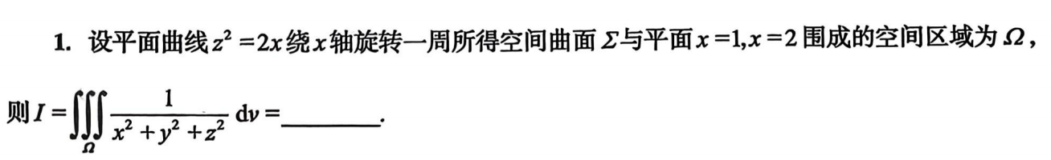
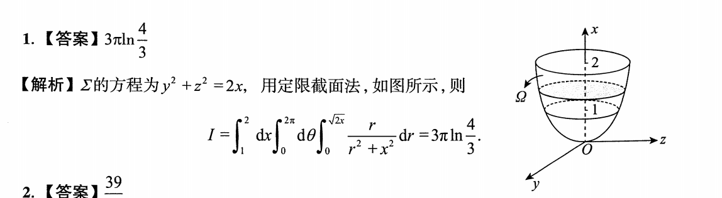
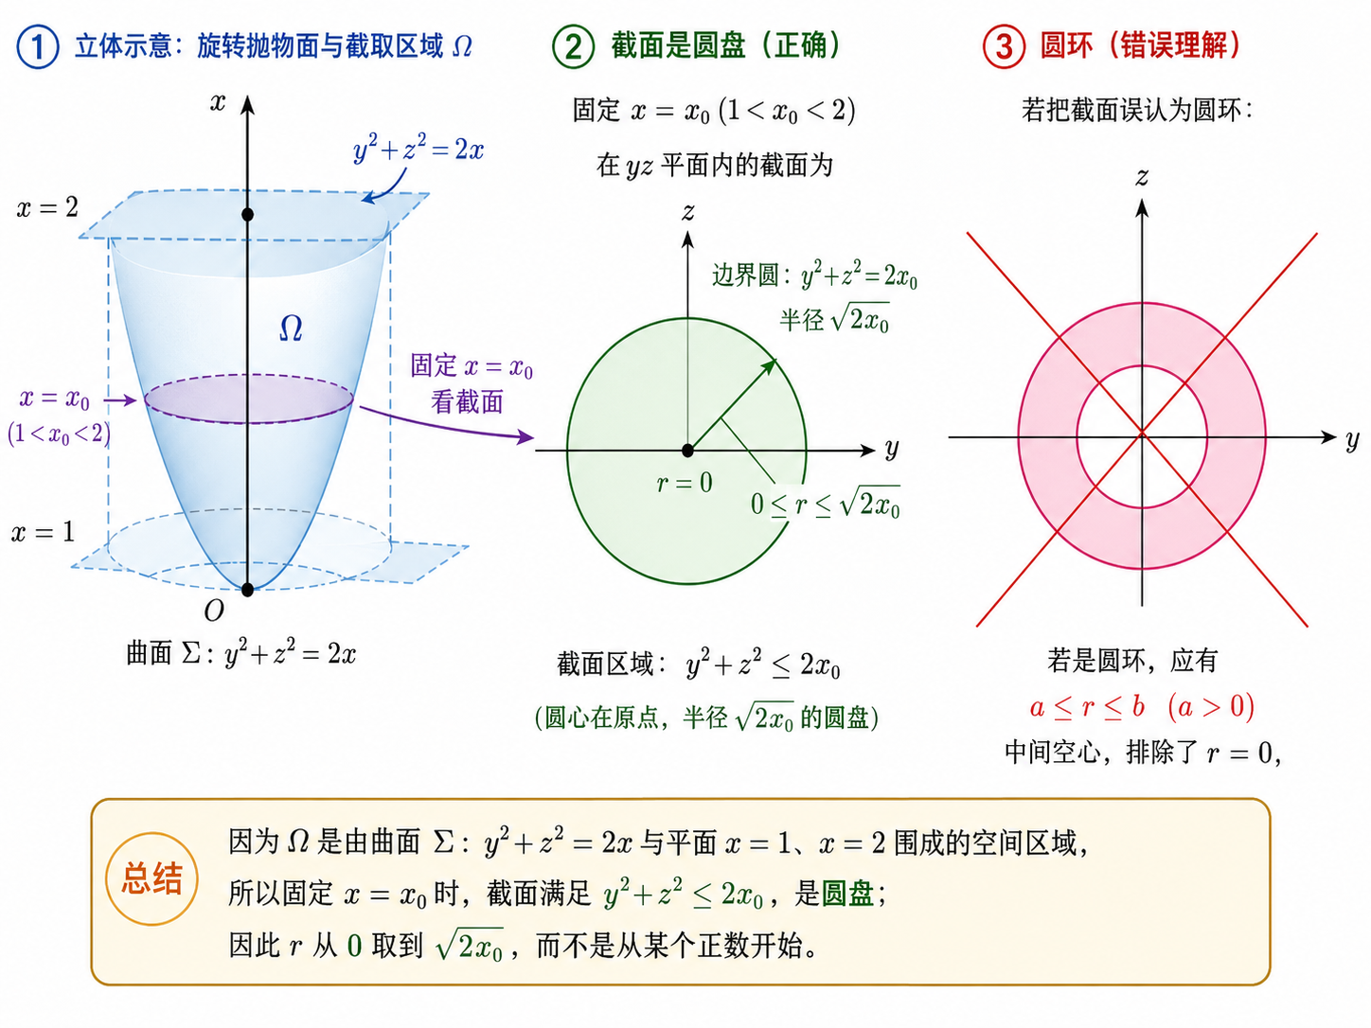

题2：
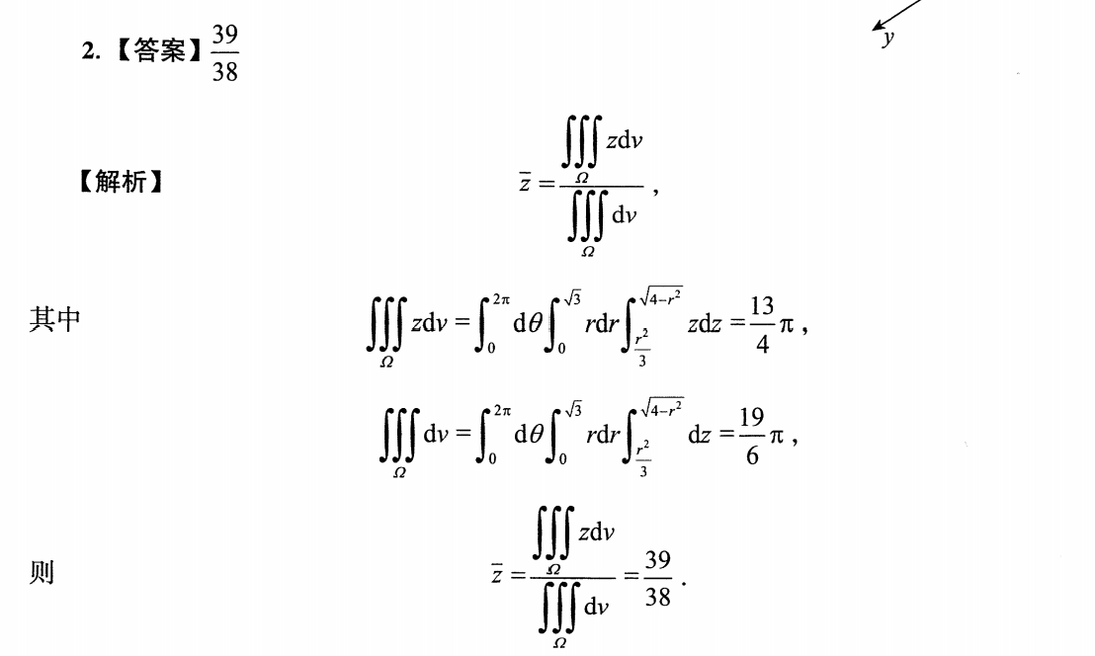

题3：
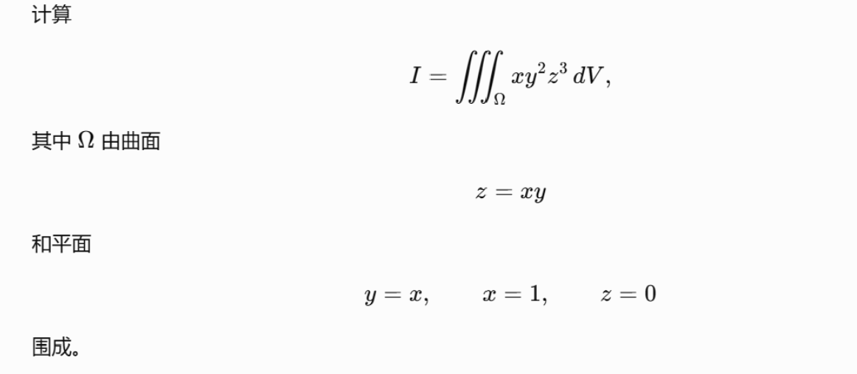
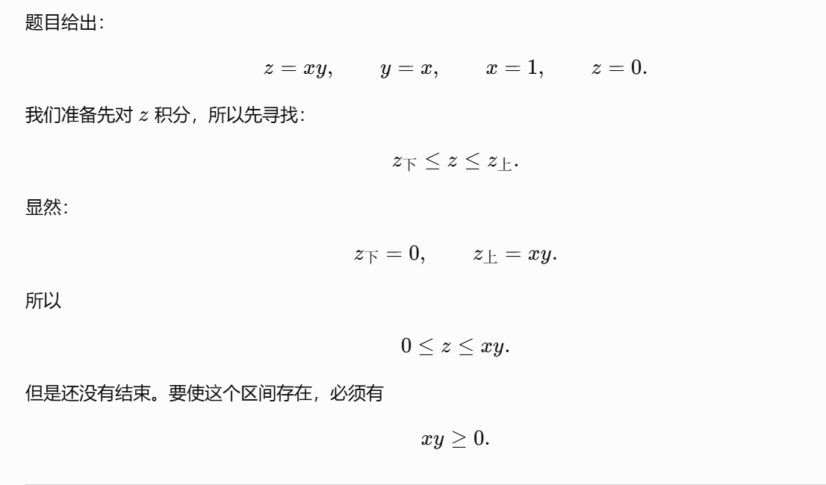
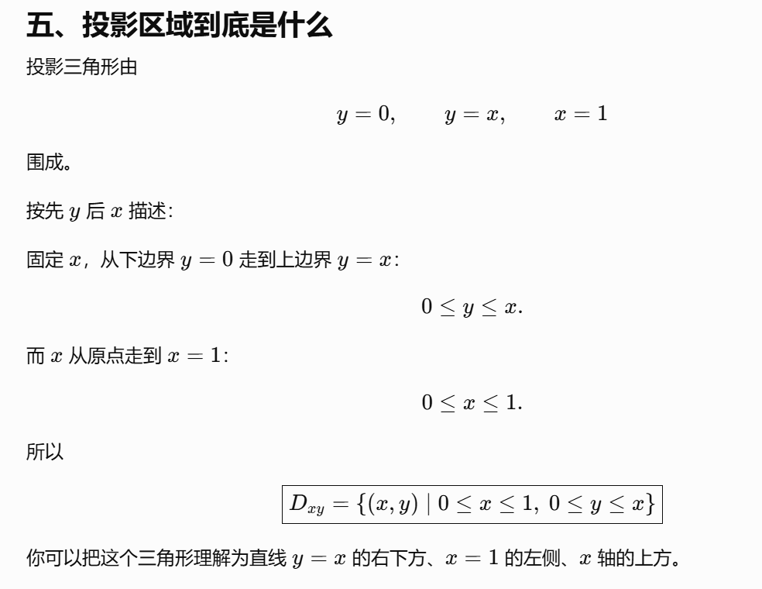
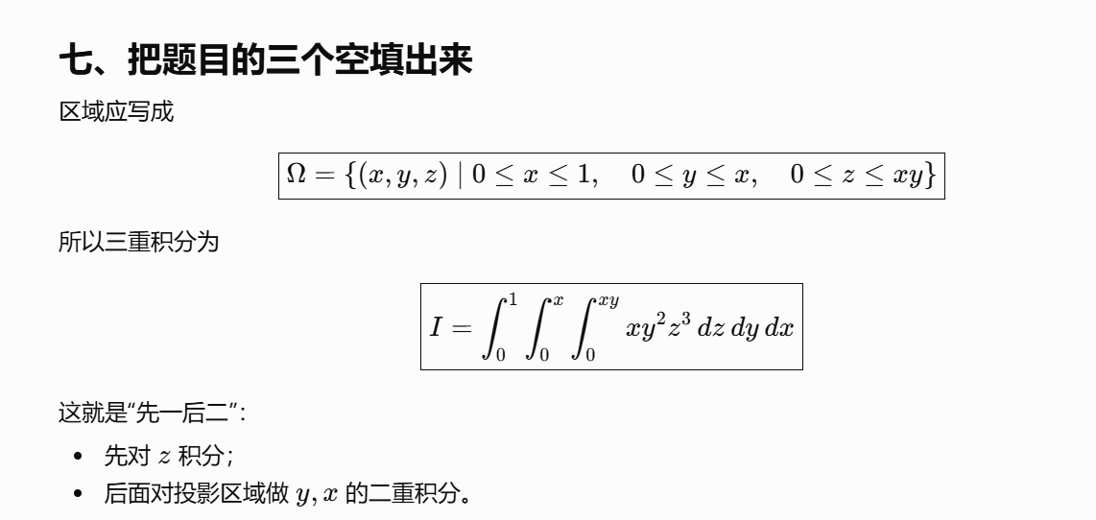
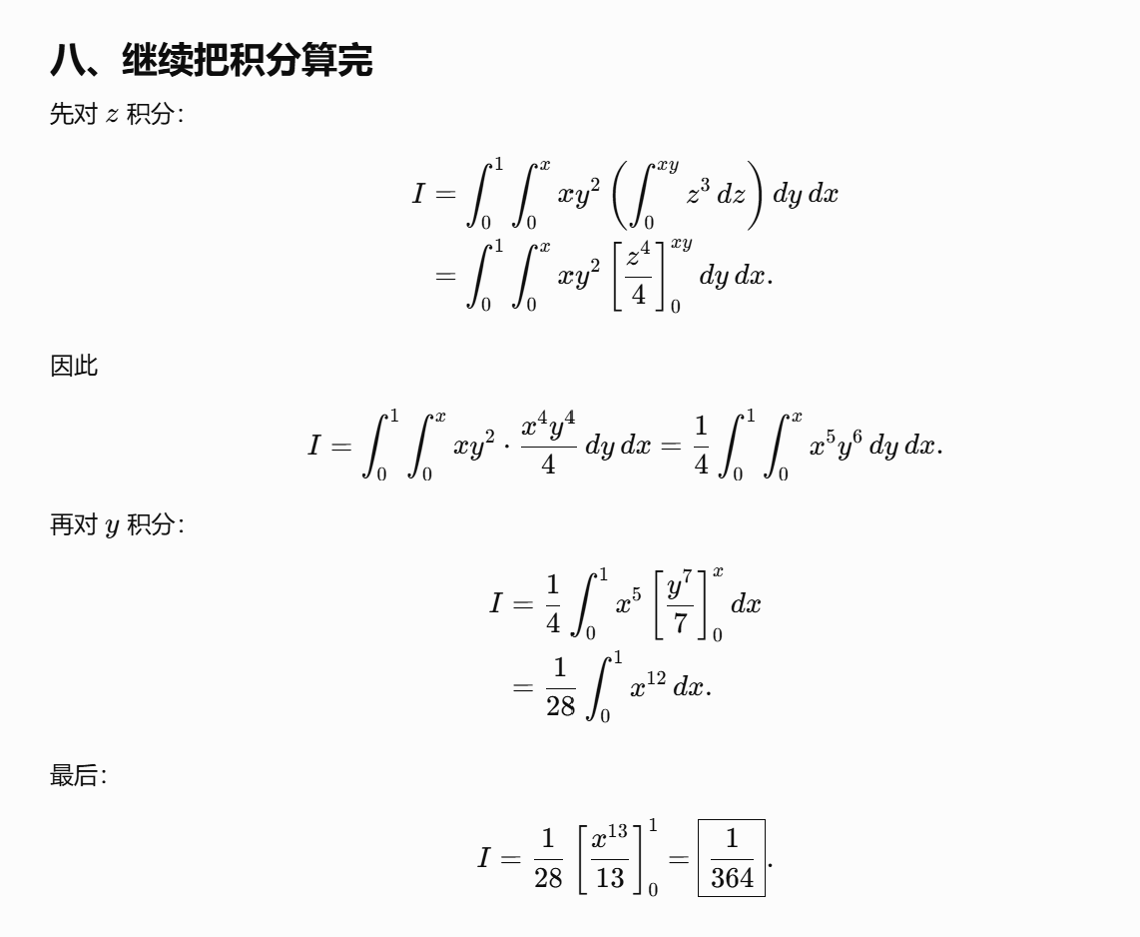

题4：
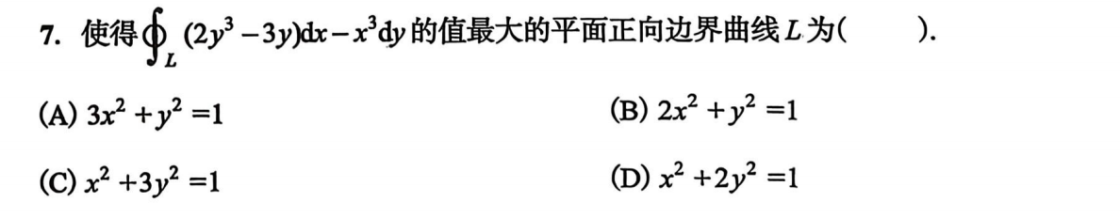
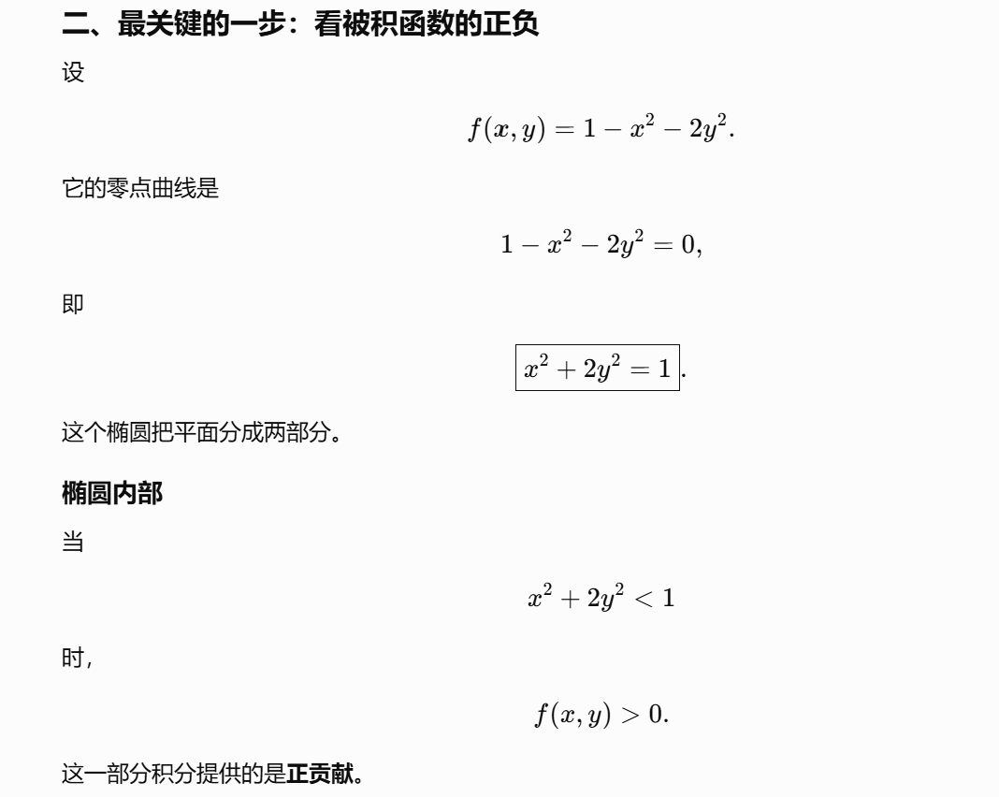
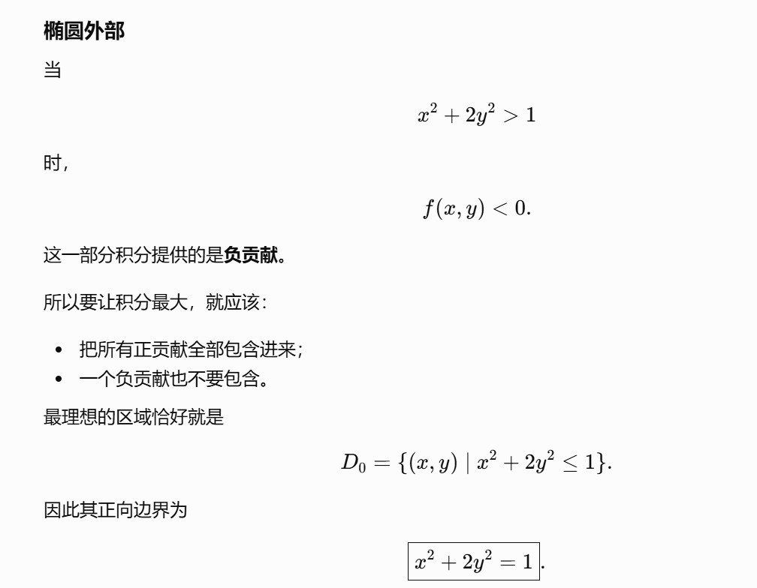
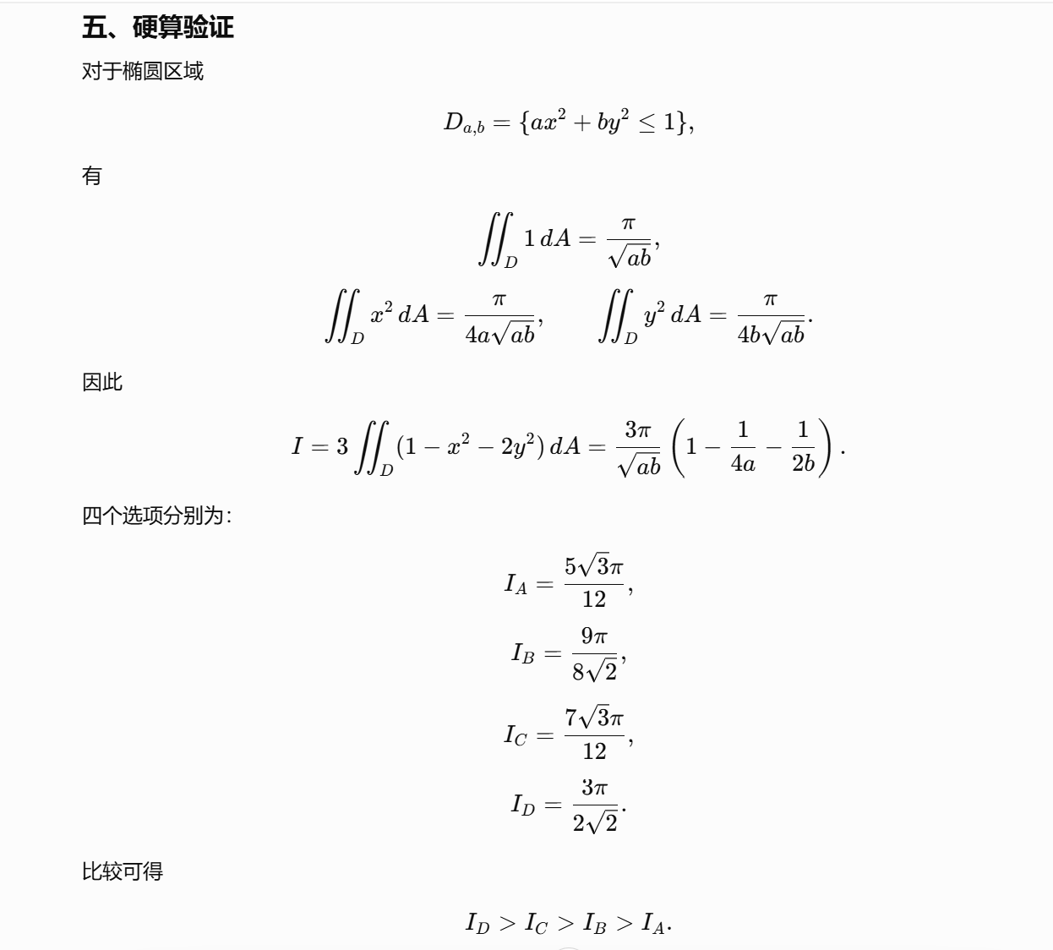

题5：
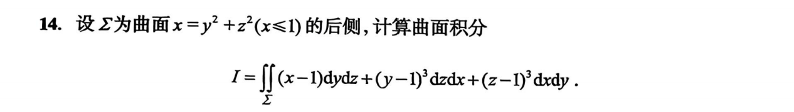
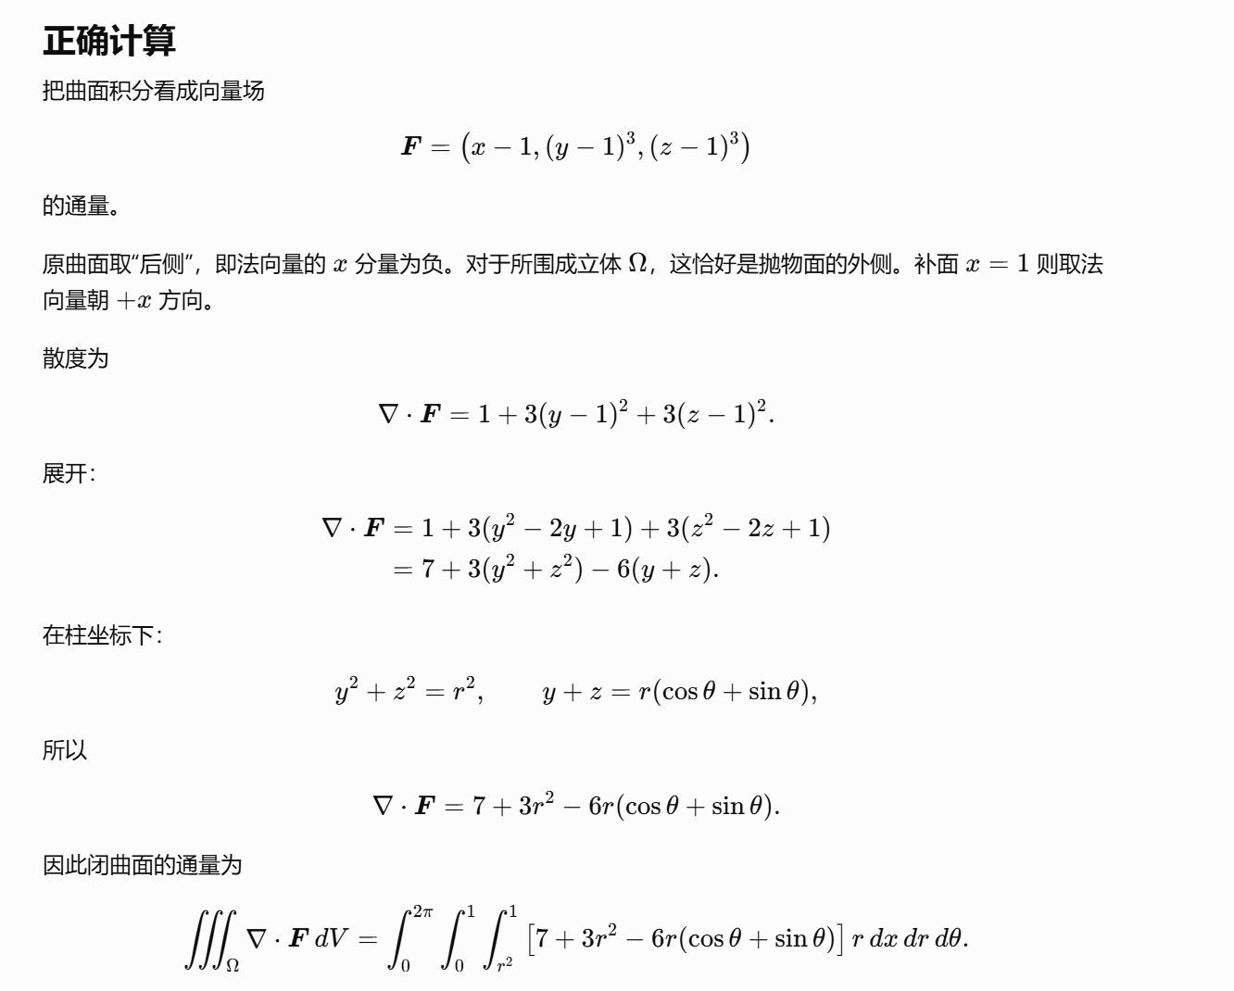
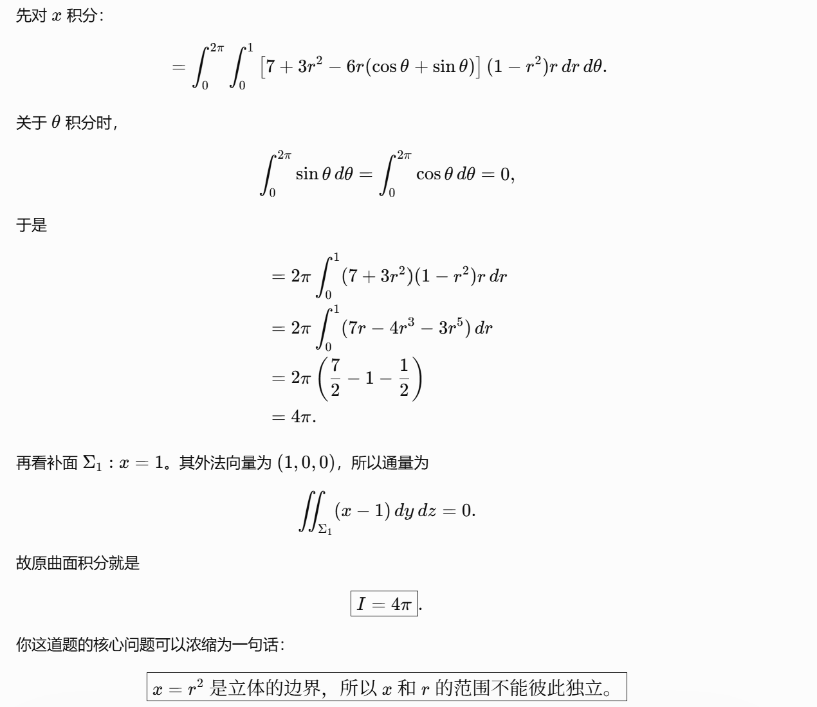
https://chatgpt.com/g/g-p-6a1d505226e08191a7f47eb8e9418ffe-gao-shu-ocr/c/6a6d9c1d-30c8-83e8-bdf3-4e7161593dc4

题6：
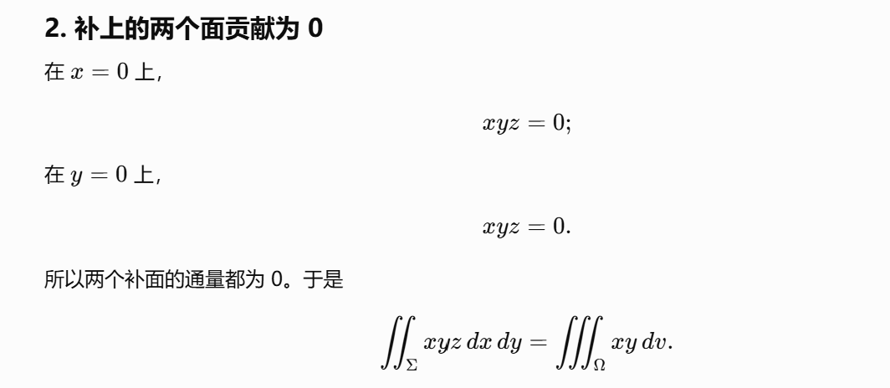
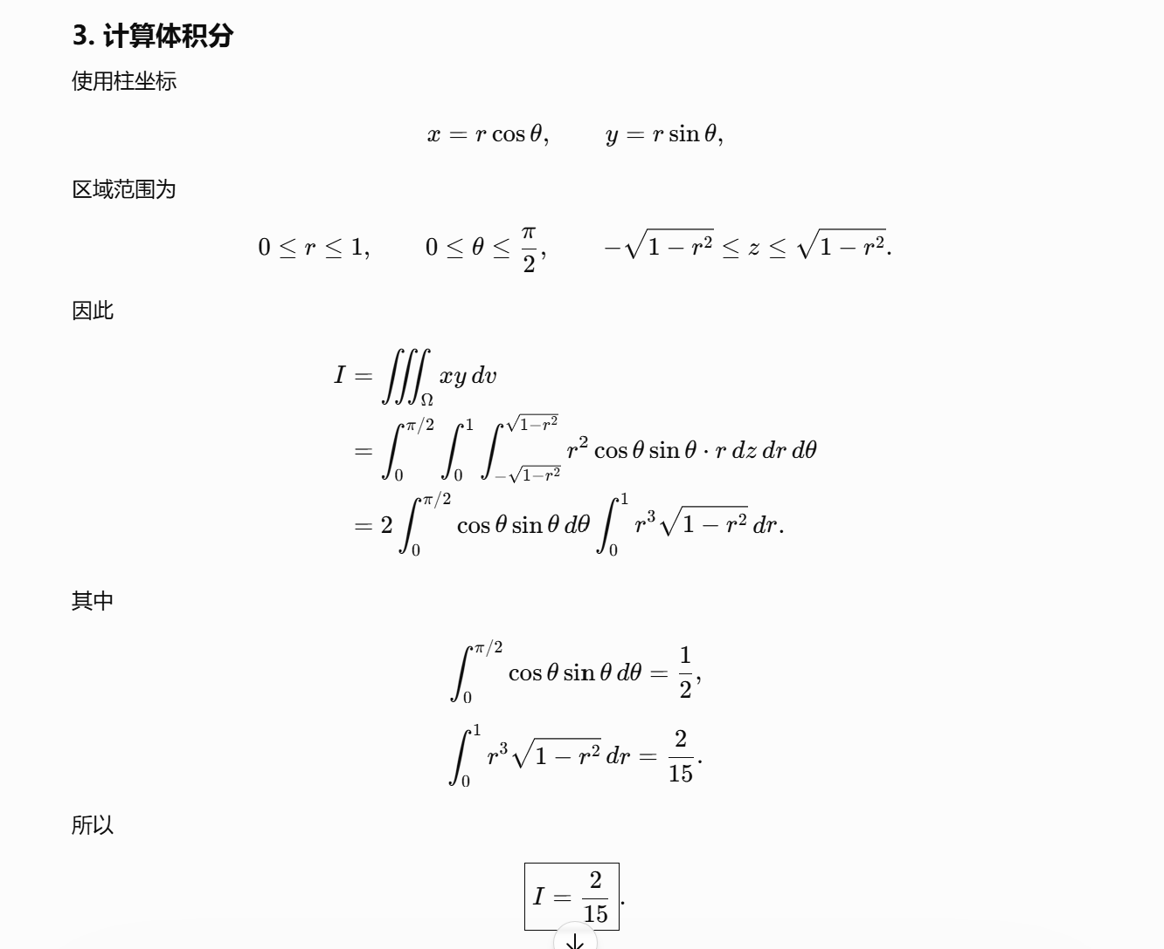
https://chatgpt.com/g/g-p-6a1d505226e08191a7f47eb8e9418ffe-gao-shu-ocr/c/6a6d9bbf-10d0-83e8-9a95-ef922914b643

题7：
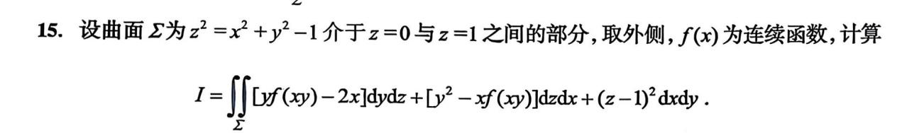
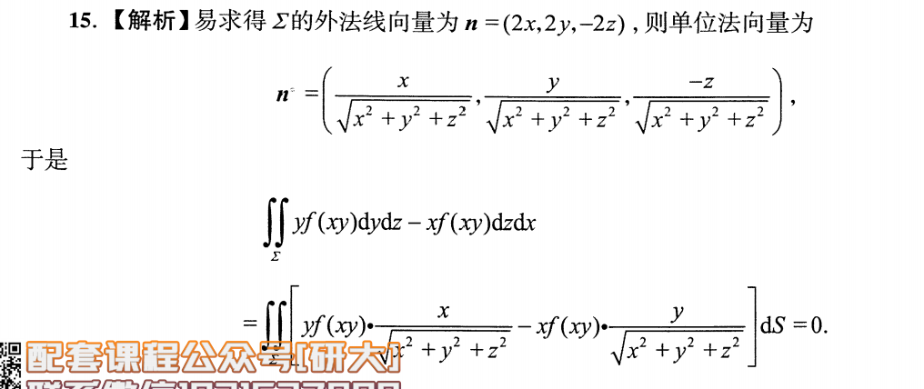
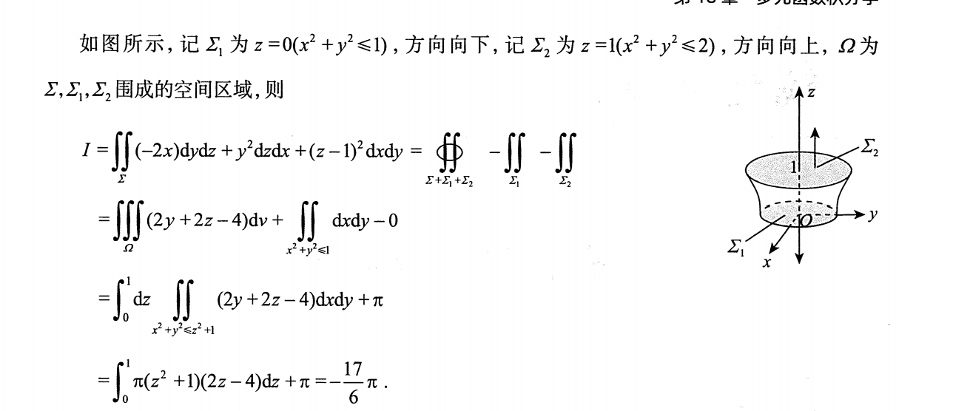
https://chatgpt.com/c/6a6eb2cc-3344-83ee-8f40-2fd7524025a3
https://chatgpt.com/g/g-p-6a1d505226e08191a7f47eb8e9418ffe-gao-shu-ocr/c/6a6ebaa8-d038-83ee-8730-1cb67db70902

题8：
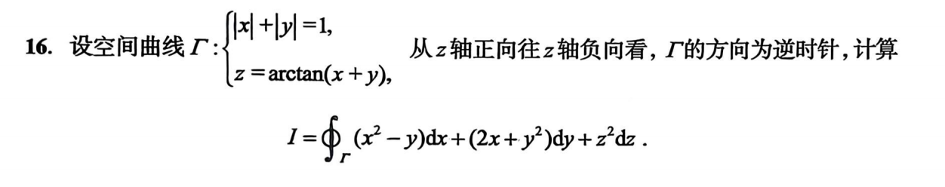
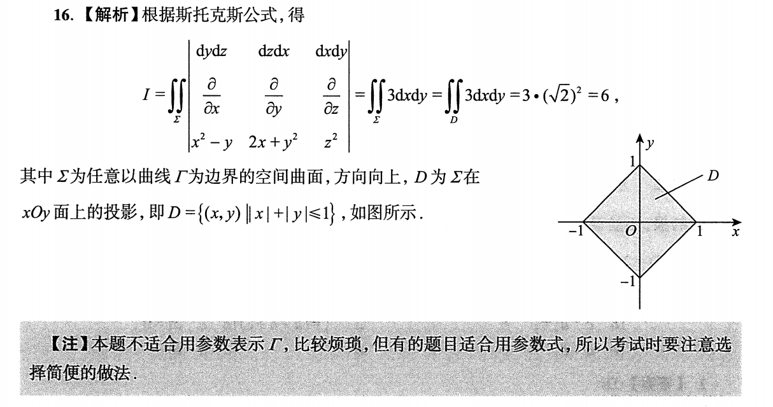
https://chatgpt.com/g/g-p-6a1d505226e08191a7f47eb8e9418ffe-gao-shu-ocr/c/6a6ece58-6fbc-83ee-b863-95511ede1c2c

题9(*)：
补线
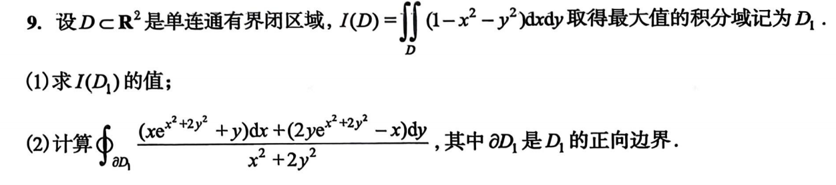
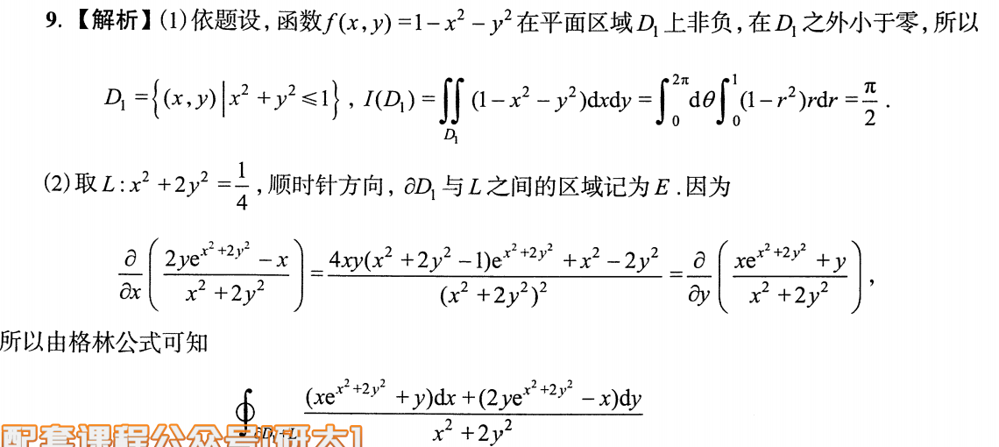
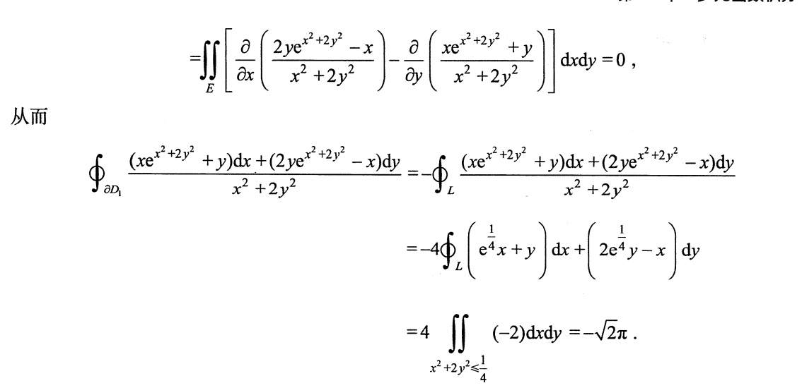
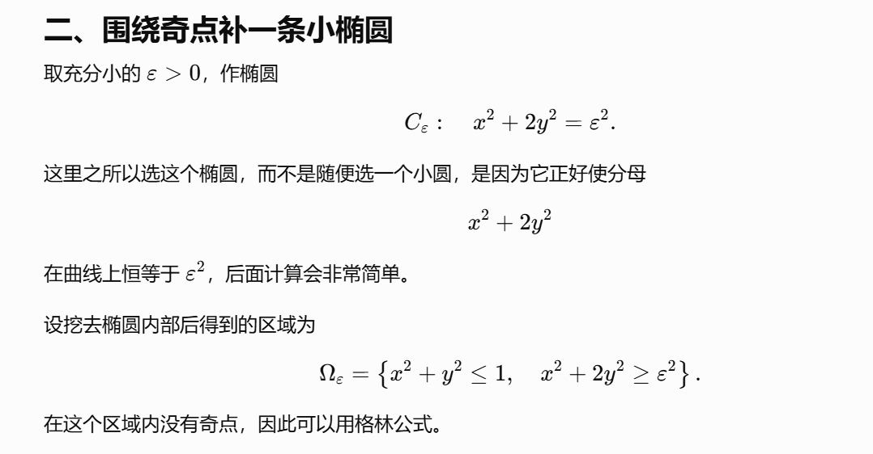
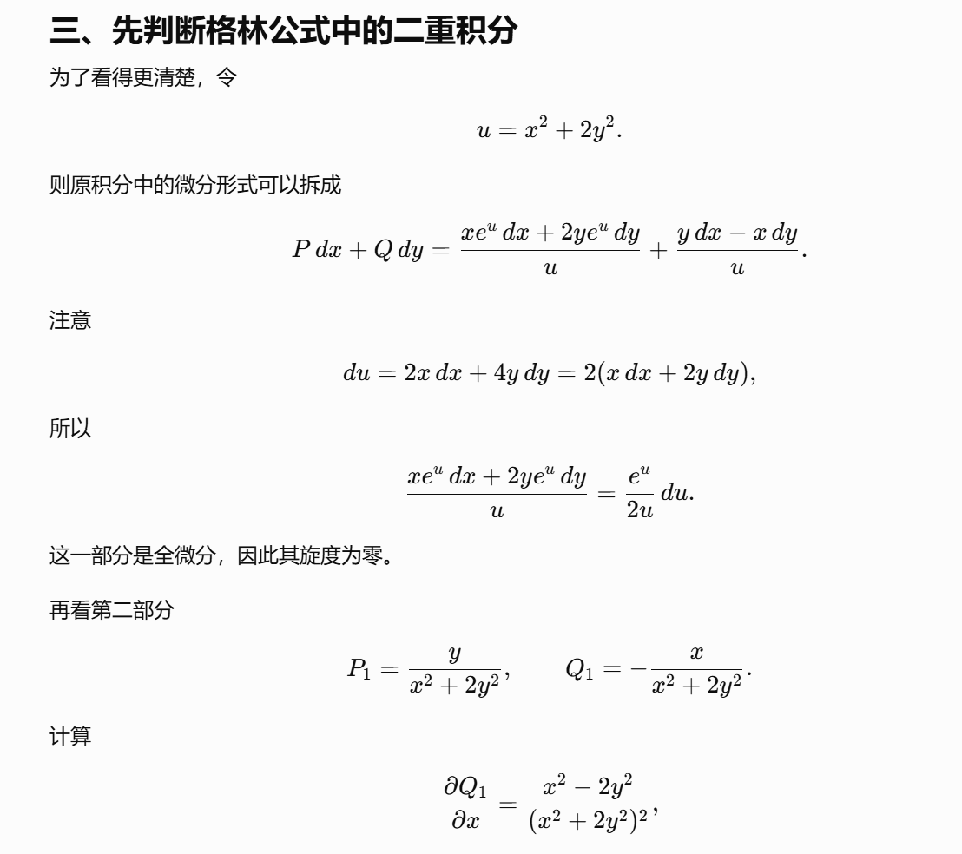

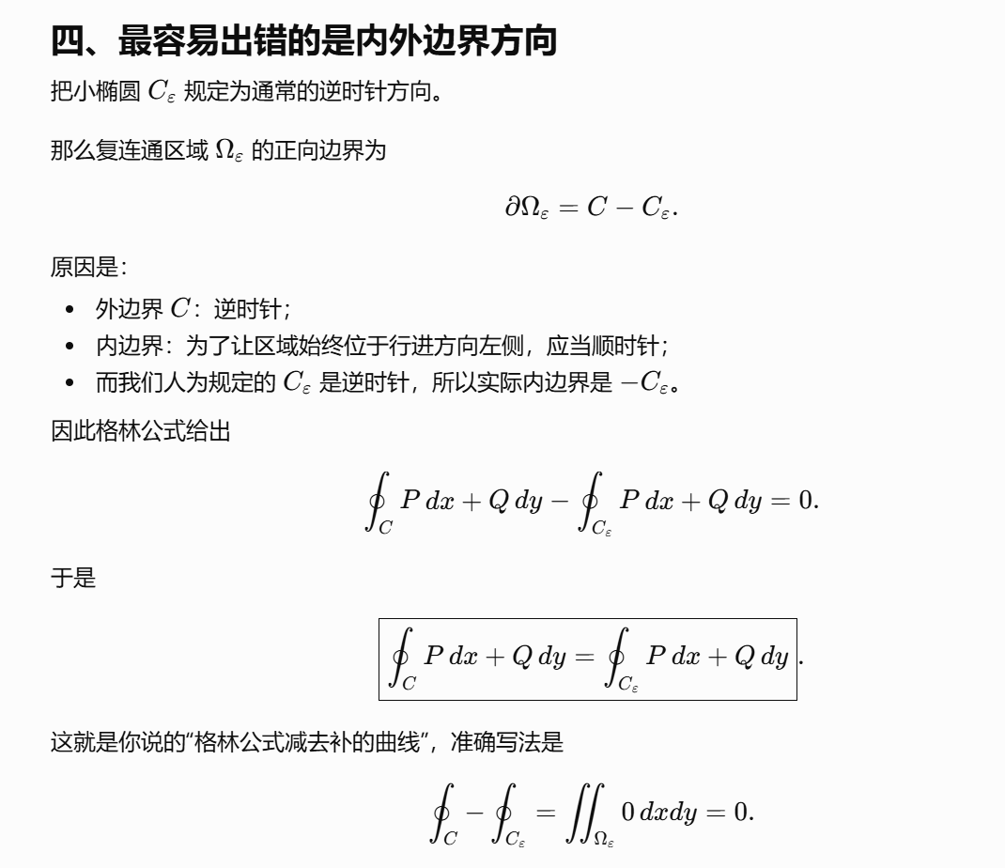
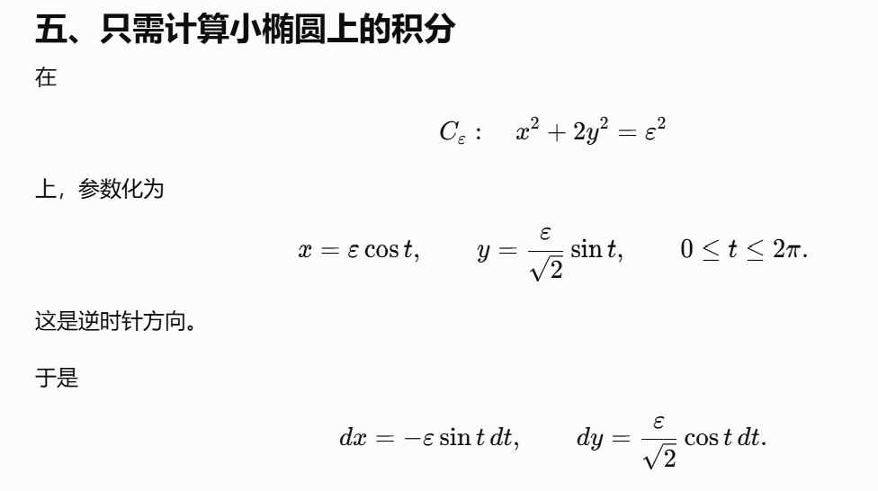
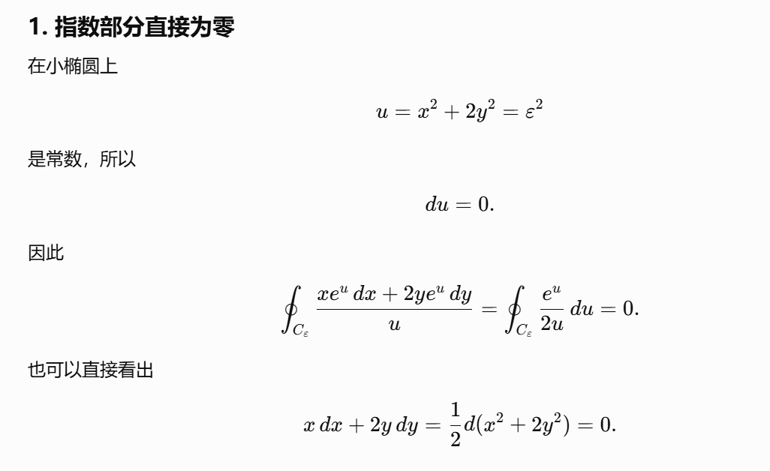
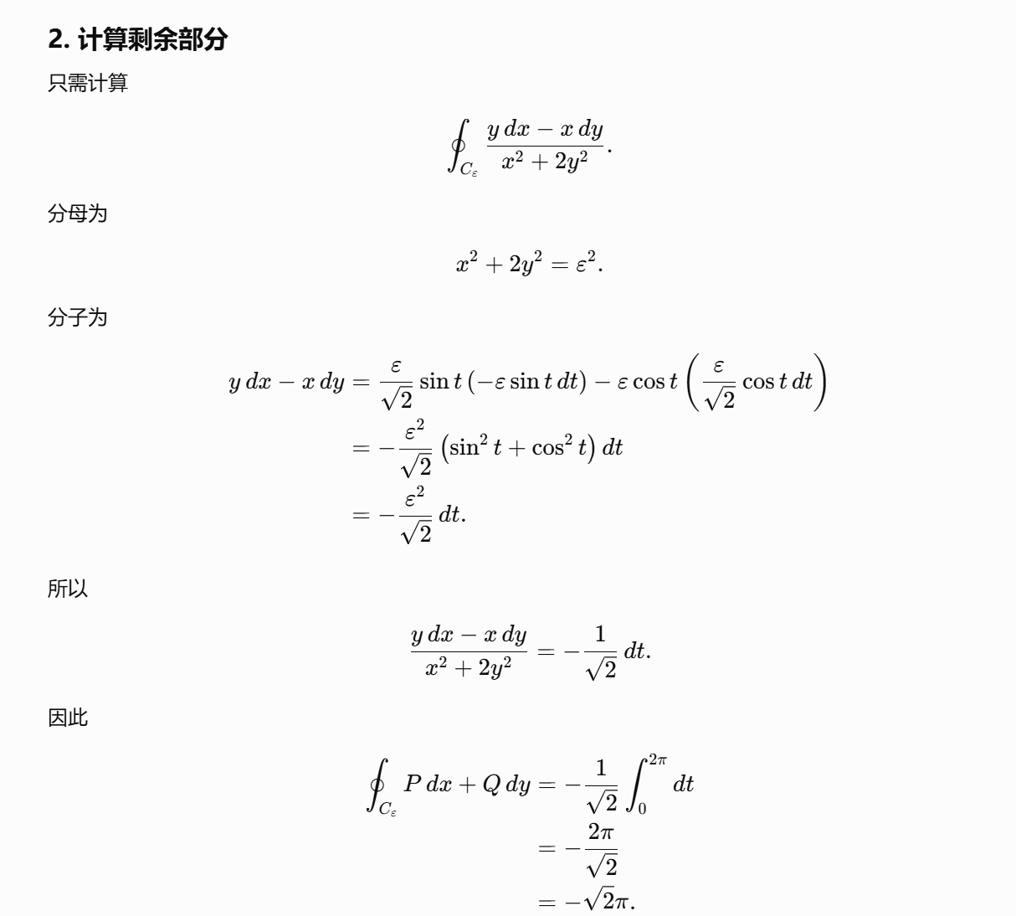

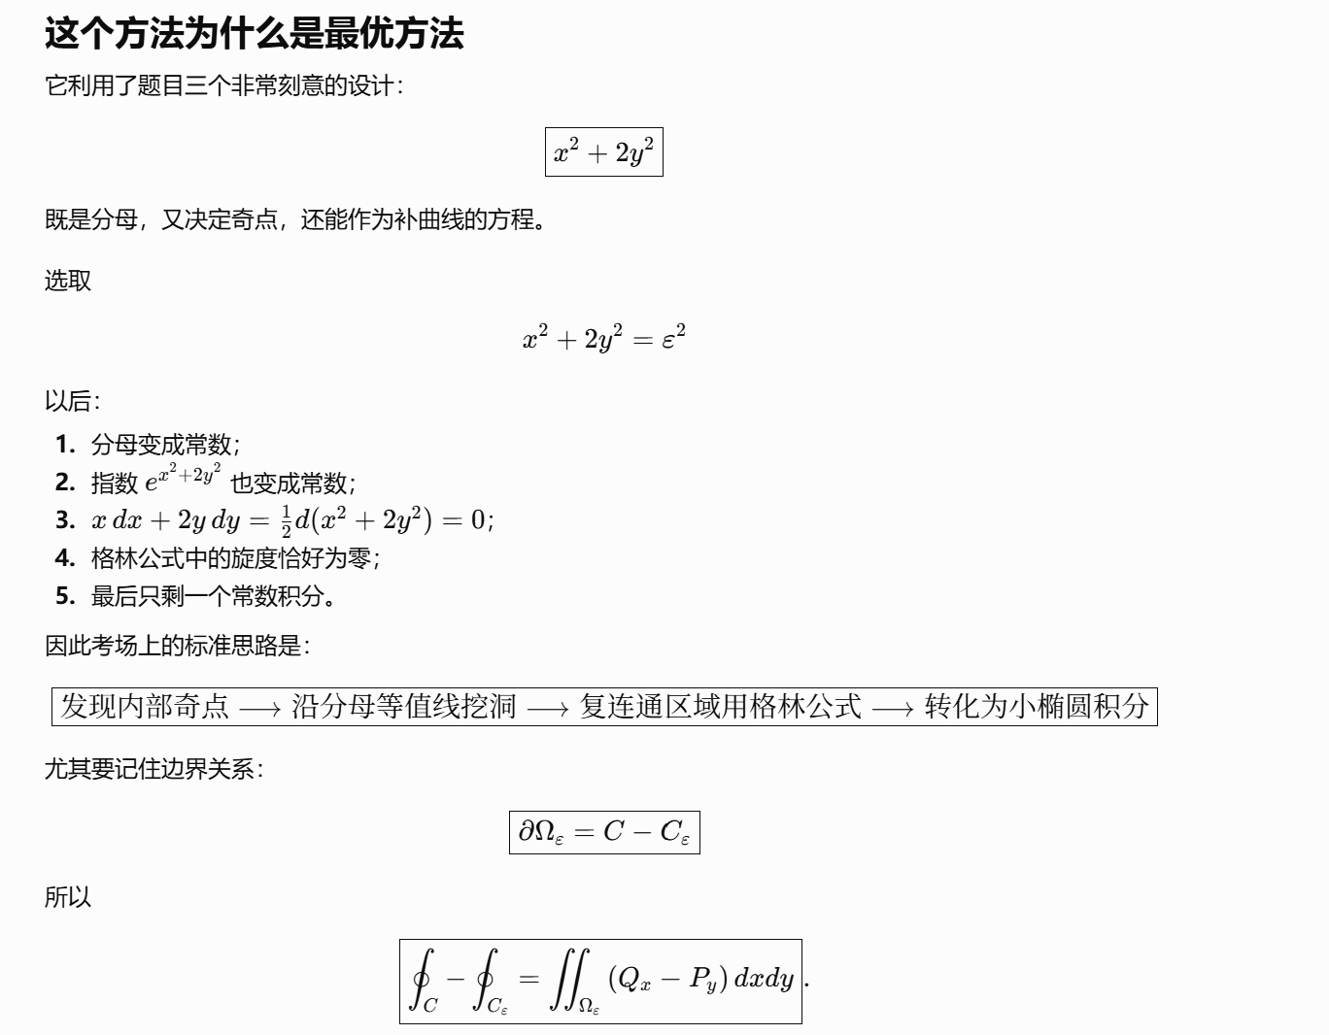
https://chatgpt.com/g/g-p-6a1d505226e08191a7f47eb8e9418ffe-gao-shu-ocr/c/6a6ed1dc-16c0-83ee-8c1f-8284aa583ef5
|（注：部分内容可能由 AI 生成）

